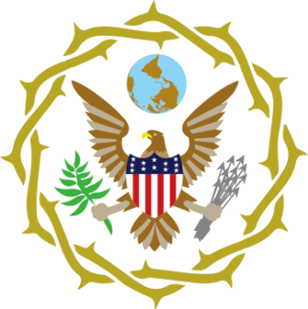
OPERATION EAGLE
The Plan For The Evangelization Of The USA For The SoldOut Movement
“Those who hope in the Lord will renew their strength. They will soar on wings like eagles; they will run and
not grow weary, they will walk and not be faint.” Isaiah 40:31

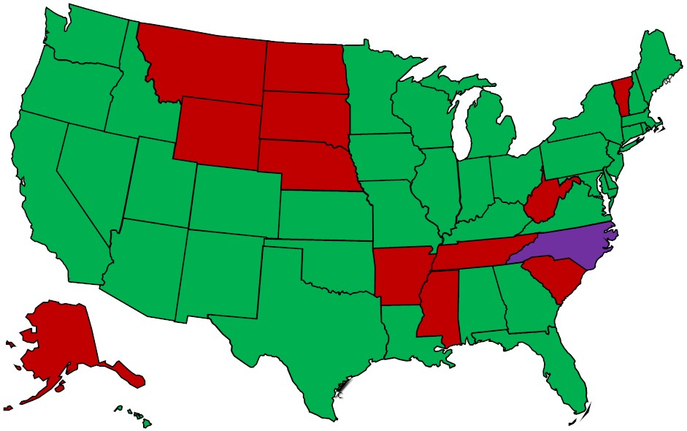

(Green – Church Planting Purple – Remnant Group Red – To Be Planted)
2023 – Bozeman, MT; Burlington, VT; Columbia, SC; Knoxville, TN; Laramie, WY; Lincoln, NE; Sioux Falls, SD
2024 – Anchorage, AK; Fayetteville, AR; Grand Forks, ND; Morgantown, WV; Raleigh, NC; Starkville, MS

States Planted 37 States To Be Planted 13

